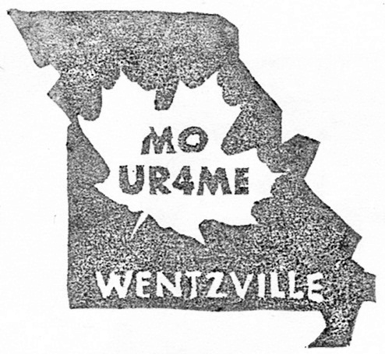
Letterboxing 101
by MO UR4Me
LETTERBOXING IS…
1. A letterbox is a hidden container somewhere in a public place. It is often in a scenic area or a place with historical significance. It’s good way to see new places and even make new friends! And it’s cheap entertainment!
2. A letterbox contains a rubber stamp and a logbook .
3. Letterboxers use a trailname .
4. Clues are found at www.AtlasQuest.com (AQ) or www.letterboxing.org (LBNA).
5. Check to see if it has been found recently. (On AQ click "Show Finds"; on LBNA log in and click green flag.)
6. Read the clues first, just in case there is something else you need before you go.
7. When you go hunt for a letterbox, you need to bring your:
a) clues d) personal logbook g) compass
b) signature stamp e) pen h) paper towel
c) ink pad or markers f) hiking gear: water bottle, bug spray, snack, cell phone, first aid kit, etc.
FINDING LETTERBOXES
RULES ("Code of Conduct")
SAFETY – poison ivy, snakes, spiders, using sticks, partner, cell phone
STEALTH – move away, pretend to take a photo, tie your shoe, have a snack, use phone
RESPECT – for nature: leave the area better than you found it: DONT disturb nature by: littering, leaving a trail to the box, breaking the sod, removing native vegetation, disturbing natural rock formations, taking apart rock walls or interfering with animals or their habitats.
for people: reseal and rehide well, replacing it exactly as you found it, report your find.
8. A “pace” equals two steps .
9. Only one person from your group should leave the trail so that new social trails aren't made.
10. Don’t let any muggles see you!
11. When you find the letterbox, you stamp:
a) YOUR stamp in the BOX’s logbook, with your trailname, the date & where you’re from.
Try not to use up an entire page, please!
b) the LETTERBOX stamp in YOUR logbook, with the date found and the planter’s trailname.
12. Don’t clean off a stamp with a baby wipe ; it can ruin the stamp.
13. You might find a hitchhiker ! (Learn more about them on AtlasQuest.com. Don't take it unless you can move it on.)
14. Check for bonus clues in the back of the book. Not many have extra clues, but some do.
15. Make sure to rehide it very well, just like you found it. Sealed, right-side up, covered up.
16. PLEASE log your find online; this helps planter know it's OK and future finders to know it's still there!

